1. Define Kernel. Explain different types of kernel data structures with neat sketch. (6M)

* ***Kernel is a computer program that is a core or heart of an operating system.***
* Kernel is the core part of an OS (Operating system); hence it has full control over everything in the system. Each operation of hardware and software is managed and administrated by the kernel.
* It acts as a bridge between applications and data processing done at the hardware level. It is the central component of an OS.
* It is the part of the OS that always resides in computer memory and enables the communication between software and hardware components.

We briefly describe several fundamental data structures used extensively in operating systems.

* The following are Different types of Kernel data structures are:
* **Array:** An array is a simple data structure in which each element can be accessed directly.
* **In a singly linked list**, each item points to its successor.
* **In a doubly linked list**, a given item can refer either to its predecessor or to its successor.
* **In a circularly linked list**, the last element in the list refers to the first element, rather than to null.
* **A stack** is a sequentially ordered data structure that uses the last in, first out (LIFO) principle for adding and removing items, meaning that the last item placed onto a stack is the first item removed. The operations for inserting and removing items from a stack are known as push and pop, respectively.
* **A queue**, in contrast, is a sequentially ordered data structure that uses thefirst in, first out (FIFO) principle: items are removed from a queue in the orderin which they were inserted.
* **A tree** is a data structure that can be used to represent data hierarchically. Datavalues in a tree structure are linked through parent–child relationships. In ageneral tree, a parent may have an unlimited number of children.
* **In a binary tree**, a parent may have at most two children, which we term the left childand the right child.
* **A binary search tree** additionally requires an orderingbetween the parent’s two children in which le f t child <= right child.
* A **hash function**takes data as its input, performs a numeric operation on this data, and returns a numeric value. This numeric value can then be used as an index into a table (typically an array) to quickly retrieve the data. Whereas searching for a data item through a list of size *n* can require up to *O*(*n*) comparisons in the worst case, using a hash function for retrieving data from table can be as good as *O*(1) in the worst case, depending on implementation details.

1. Define Operating System. Explain in detail different types of operating systems. (6M)

* Operating systems are there from the very first computer generation and they keep evolving with time.
* In this, we will discuss some of the important types of operating systems which are most commonly used.

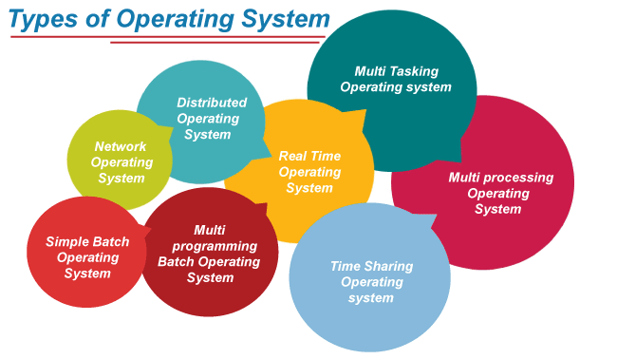

**Batch Operating System**

In the 1970s, Batch processing was very popular. In this technique, similar types of jobs were batched together and executed in time. People were used to having a single computer which was called a mainframe.

In Batch operating system, access is given to more than one person; they submit their respective jobs to the system for the execution.

The system put all of the jobs in a queue on the basis of first come first serve and then executes the jobs one by one. The users collect their respective output when all the jobs get executed.

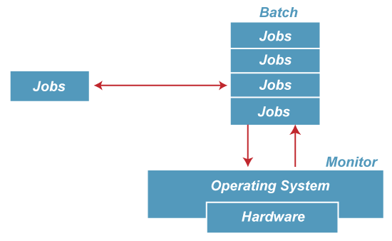

The purpose of this operating system was mainly to transfer control from one job to another as soon as the job was completed. It contained a small set of programs called the resident monitor that always resided in one part of the main memory. The remaining part is used for servicing jobs.

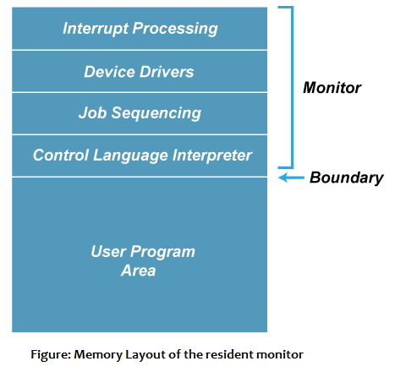

Advantages of Batch OS

* The use of a resident monitor improves computer efficiency as it eliminates CPU time between two jobs.

Disadvantages of Batch OS

**1. Starvation**

Starvation is the problem that occurs when high priority processes keep executing and low priority processes get blocked for indefinite time.

That is , Batch processing suffers from starvation.

**For Example:**

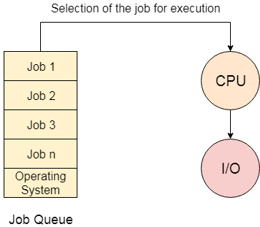

There are five jobs J1, J2, J3, J4, and J5, present in the batch. If the execution time of J1 is very high, then the other four jobs will never be executed, or they will have to wait for a very long time. Hence the other processes get starved.

**2. Not Interactive**

Batch Processing is not suitable for jobs that are dependent on the user's input. If a job requires the input of two numbers from the console, then it will never get it in the batch processing scenario since the user is not present at the time of execution.

**Multiprogramming Operating System**

Multiprogramming is an extension to batch processing where the CPU is always kept busy. Each process needs two types of system time: CPU time and IO time.

In a multiprogramming environment, when a process does its I/O, The CPU can start the execution of other processes. Therefore, multiprogramming improves the efficiency of the system.

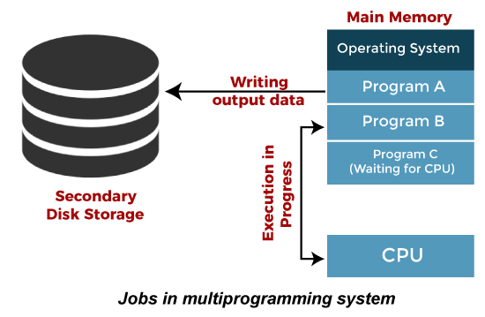

Advantages of Multiprogramming OS

* Throughout the system, it increased as the CPU always had one program to execute.
* Response time can also be reduced.

Disadvantages of Multiprogramming OS

* Multiprogramming systems provide an environment in which various systems resources are used efficiently, but they do not provide any user interaction with the computer system.

**Multiprocessing Operating System**

In Multiprocessing, Parallel computing is achieved. There are more than one processors present in the system which can execute more than one process at the same time. This will increase the throughput of the system.

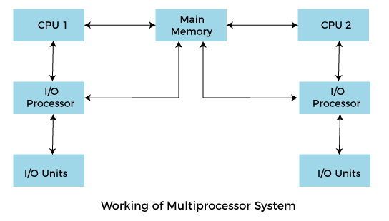

In Multiprocessing, Parallel computing is achieved. More than one processor present in the system can execute more than one process simultaneously, which will increase the throughput of the system.

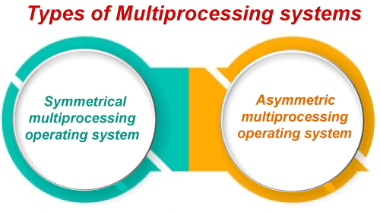

**Advantages of Multiprocessing operating system:**

* **Increased reliability:** Due to the multiprocessing system, processing tasks can be distributed among several processors. This increases reliability as if one processor fails, the task can be given to another processor for completion.
* **Increased throughout:** As several processors increase, more work can be done in less.

**Disadvantages of Multiprocessing operating System**

* Multiprocessing operating system is more complex and sophisticated as it takes care of multiple CPUs simultaneously.

**Multitasking Operating System**

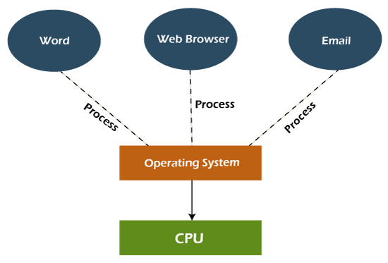

The multitasking operating system is a logical extension of a multiprogramming system that enables **multiple** programs simultaneously. It allows a user to perform more than one computer task at the same time.

Advantages of Multitasking operating system

* This operating system is more suited to supporting multiple users simultaneously.
* The multitasking operating systems have well-defined memory management.

Disadvantages of Multitasking operating system

* The multiple processors are busier at the same time to complete any task in a multitasking environment, so the CPU generates more heat.

1. Define process. Explain the process state diagram and PCB with neat sketch. (6M)

* **A process is basically a program in execution.**
* The execution of a process must progress in a sequential fashion.
* A process is defined as an entity which represents the basic unit of work to be implemented in the system.
* To put it in simple terms, we write our computer programs in a text file and when we execute this program, it becomes a process which performs all the tasks mentioned in the program.

**Process Life Cycle Methods**

When a process executes, it passes through different states. These stages may differ in different operating systems, and the names of these states are also not standardized. In general, a process can have one of the following five states at a time.

Processes in the operating system can be in any of the following states:

* NEW- The process is being created.
* READY- The process is waiting to be assigned to a processor.
* RUNNING- Instructions are being executed.
* WAITING- The process is waiting for some event to occur (such as an I/O completion or reception of a signal).
* TERMINATED- The process has finished execution.

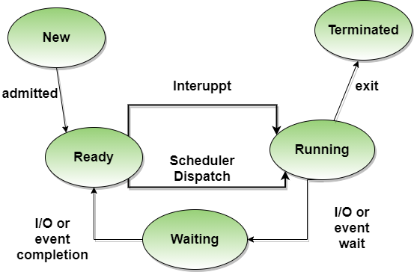

**Fig: Process state diagram**

1. **Process Control Block (PCB):**

* **A Process Control Block is a data structure maintained by the Operating System for every process. The PCB is identified by an integer process ID (PID).**
* The PCB is maintained for a process throughout its lifetime, and is deleted once the process terminates.
* The architecture of a PCB is completely dependent on Operating System and may contain different information in different operating systems. Here is a simplified diagram of a PCB–

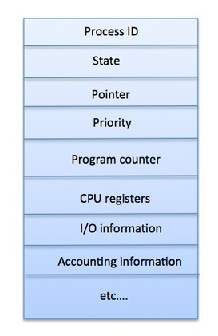

A PCB keeps all the information needed to keep track of a process as listed below in the table –

|  |  |
| --- | --- |
| **S.N.** | **Information & Description** |
| 1 | **Process State**  The current state of the process i.e., whether it is ready, running, waiting, or whatever. |
| 2 | **Process privileges**  This is required to allow/disallow access to system resources. |
| 3 | **Process ID**  Unique identification for each of the process in the operating system. |
| 4 | **Pointer**  A pointer to parent process. |
| 5 | **Program Counter**  Program Counter is a pointer to the address of the next instruction to be executed for this process. |
| 6 | **CPU registers**  Various CPU registers where process need to be stored for execution for running state. |
| 7 | **CPU Scheduling Information**  Process priority and other scheduling information which is required to schedule the process. |
| 8 | **Memory management information**  This includes the information of page table, memory limits, Segment table depending on memory used by the operating system. |
| 9 | **Accounting information**  This includes the amount of CPU used for process execution, time limits, execution ID etc. |
| 10 | **IO status information**  This includes a list of I/O devices allocated to the process. |

1. Discuss various multithreading models. (6M)

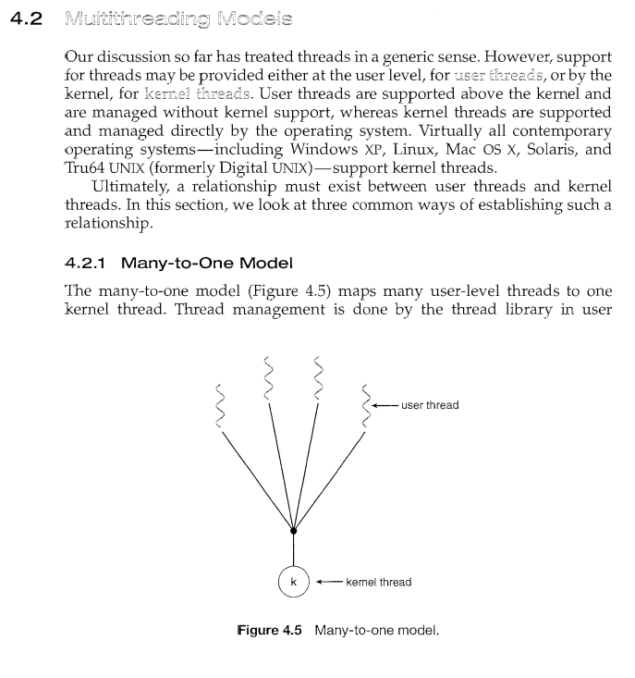

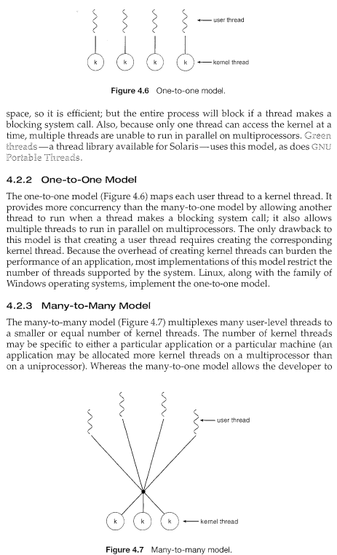

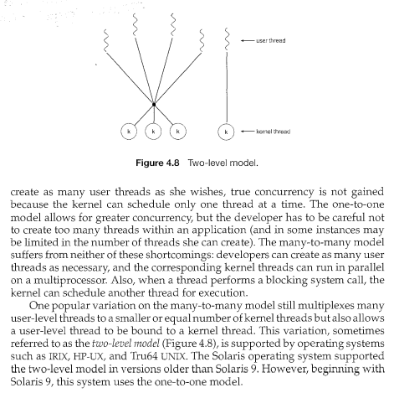

1. Write a short note on Multi processor scheduling. (6M)

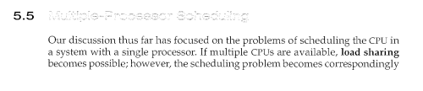

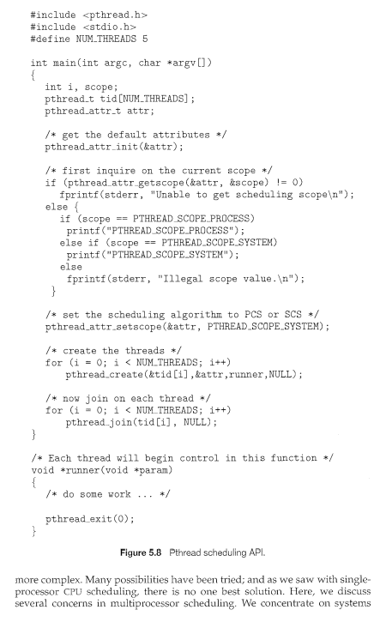

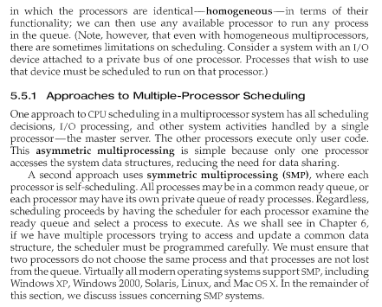

1. Differentiate multilevel queue and multilevel feedback queue scheduling with an example. (6M)

